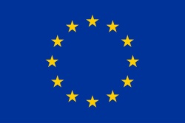

|  |
| --- |
| Note accompanying the release of the first stabilized version of the MICA Dynamic Decision Graph (DDG) |
| **MICA D6.0 DELIVERABLE** |

*Delivered on 16 December 2016*

***Synthesis of BRGM, BGS, GeoZS, GEUS, GTK, JRC and LIG contributions***

Content

1. Introduction 4

2. Development of the ontologies 5

2.1 The Main Ontology 6

2.2 Transversal generic ontologies 8

3. FactSheets, docSheets and flowSheets 9

3.1 FactSheet structure 10

3.2 FactSheet and docSheet production 12

3.3 Flowsheets 15

4. Architecture and implementation 16

4.1 Architecture 16

4.2 Implementation of MICA ontology 17

4.3 MICA sheets annotation 19

4.4 Implementation of the queries 21

4.5 MICA’s development server 24

5. Prototype of the Dynamic Decision Graph (DDG) 24

6. Concluding remarks 27

**Figures**

*Figure 1- WP6 objective, and the Dynamic Decision Graph 5*

*Figure 2- Development of the Main Ontology and of transversal ontologies. 6*

*Figure 3- The 8 domains of the Main Ontology 7*

*Figure 4 - The Main Ontology and its concepts and sub-concepts. 8*

*Figure 5- Transversal ontologies. 9*

*Figure 6 - FactSheet structure and indexation. 11*

*Figure 7 - FactSheet ontology. 12*

*Figure 8 – MICA Architecture 17*

*Figure 9 – SKOS ontology implementation 18*

*Figure 10 – VocBench user interface displaying MICA Main (domains) ontology. 19*

*Figure 11 – MICA Model to represent fact, documentation and definition sheets. 20*

*Figure 12: – Web interface to annotate a factSheet. 21*

*Figure 13 – Using the concepts hierarchy to retrieve factsheets and relevant methods. 23*

*Figure 14 – Federated query to retrieve data form MICA database and external databases 23*

*Figure 15 – MICA GitHub repository for WP6 developments. 24*

*Figure 16 – Landing DDG Prototype page 25*

*Figure 17 – Ontology selection and a consequent filtering of the factSheets 26*

*Figure 18 – Further sub-concepts (ontology) selection and a consequent filtering of the relevant factSheets 26*

**Tables**

*Table 1- FactSheets and docSheets to be produced. Situation in Oct., 2016.* 15

*Table 2- FlowSheets example, related to exploration.* 16

**THE MICA Dynamic Decision Graph (DDG)**

## Introduction

If specialists have – at least for some facets or sub-domains - the necessary knowledge on how **to efficiently use all the data which is available to perform various studies**, most of the stakeholders do not have the essential skills allowing such an efficient use of this data for solving problems they may meet. Actually:

(i) they neither have a clear and global vision of all the methods and tools that can be used,

(ii) nor know how to implement these methods and tools, their limits of use (requisite characteristics of the initial dataset, scale, accuracy…),

(iii) how to choose the best available technique (BAT) to obtain the expected result(s) and/or, if necessary,

(iv) how to combine or link together several of these techniques.

The objective of the MICA project is to fill this gap in the chain of use of data and to allow the end user to select in a seamless way the best available set of technologies for answering his/her question(s)/problem(s).

To reach this objective WP6 will create a database of methodologies and tools descriptions (these descriptions are called here ‘factSheets’ and ‘flowSheets’, the first ones describing single methods/tools, and the second ones describing how to link several methods (and the data) for answering complex queries) with an ontology-based interface to visualize the database content and the relationships between the different techniques, and to search for the most appropriate method(s) and tool(s) (Figure 1).

|  |
| --- |
|  |

Figure 1- WP6 objective, and the Dynamic Decision Graph

## Development of the ontologies

The development of the Main Ontology and of transversal ‘generic’ (Figure 2) ontologies results from a collaborative and iterative action within the project, involving several of the partners. It must be emphasized here that this development is based on a survey performed by WP2 during the kick-off meeting in Copenhagen (Feb. 2016), and involving essentially Experts from the project. The results of this survey are thus not representative of what a large panel of end users (e.g., politicians, representatives of the Commission, from governmental agencies, NGOs, academia, and the Grand Public) may think or would have asked. This is the reason why the Main Ontology will be updated taking into account ongoing surveys from WP2, 3, 4 and 5, and improved, both in terms of perimeter and depth/granularity. Such modifications are not integrated in this version of the DDG, and will be implemented at the beginning of 2017, after a careful analysis of end-users needs.

|  |
| --- |
|  |

Figure 2- Development of the Main Ontology and of transversal ontologies.

### The Main Ontology

The Main Ontology has been first developed using an Excel spreadsheet – see the inserted spreadsheet below. It is now accessible through a VocBench application. The following slides give the main characteristics of this ontology (Figure 3 & Figure 4).

|  |  |
| --- | --- |
|  | *This file is safe. Click on the button ’Activate the modification’ when opening the file.* |

|  |
| --- |
|  |

*Figure 3- The 8 domains of the Main Ontology*

|  |
| --- |
|  |

*Figure 4 - The Main Ontology and its concepts and sub-concepts.*

### Transversal generic ontologies

In parallel to the development of the Main Ontology, transversal, more 'generic' ontologies (TrOnto) have been developed: 'Value/Supply Chain', 'EU Directives', 'Spatial/Temporal', and 'Commodities' (Figure 5). These TrOntos are described in detail within the Excel spreadsheet included above. Note that the TrOnto ‘EU Directives’ will in practice not be used and that references to directives will directly point toward the EUR-LEX site (<http://eur-lex.europa.eu/homepage.html?locale=en>), utilizing the unique EU legislation identifier CELEX.

|  |
| --- |
|  |

Figure 5- Transversal ontologies.

## FactSheets, docSheets and flowSheets

FactSheets are used to describe in detail a method or a tool, giving all the necessary information to the end user on how to implement this method for resolving a problem. DocSheets can be seen as a complementary source of information, explaining some concepts (which are not methods or tools) such as substitution, criticality… an end user may appreciate to find during his navigation on the Dynamic Decision Graph. FlowSheets can be seen as ‘cooking recipes’ allowing to answer complex queries an end user may have and which necessitates to link in a certain order several factSheets and related data.

FactSheets and flowSheets will indicate which type(s) of data are necessary for running the method(s) and their source(s). WP3 is in charge of the inventory of data/data sources and will provide WP6 with metadata related to these data sources. Each metadata will be internally indexed (i) to the fact/flowSheet using this source and (ii) to the domain(s)/concept(s)/sub-concept(s) to which it may be useful.

In the same way, fact/doc/FlowSheets are carefully indexed (or annotated over) with the domain(s)/concepts(s)/sub-concept(s) to which they can be put in relation with.

This is this collection/grouping of links which allows the selection of relevant concepts – fact/doc/flowSheets and data to suggest to the end user one or several (ranked on pertinence) answers making sense.

### FactSheet structure

The structure of a factsheet is described in Figure 6, with a snapshot of the DDG (prototype version 1 – Sept., 2016) showing the indexation over the concepts and sub-concepts of the Main Ontology. For the sake of homogeneity, the same template is used to produce docSheets, non-relevant sections being left empty.

|  |
| --- |
|  |

*Figure 6 - FactSheet structure and indexation.*

It is noteworthy that factSheets are also modeled with a dedicated ontology (Figure 7), allowing the user (end user or producer) to retrieve detailed information related to the factsheet, e.g., the author, the organization…

|  |
| --- |
|  |

*Figure 7 - FactSheet ontology.*

### FactSheet and docSheet production

Nearly all MICA work packages (i.e., WP3, WP4, WP5 and WP6) are involved in factSheets production. Table 1 summarizes which factSheets were planned to be produced after an interactive process including (i) the analysis of the possible end-user questions (resulting from the WP2 meeting survey in Copenhagen), (ii) the concomitant development/refining of the Main Ontology and (iii) the mapping of the questions over the domains and concepts.

This mapping (see inserted Excel spreadsheet above, last folder) will be redone (process under way) in order to take into account the more detailed surveys realized in the frame of WP2, and both the perimeter and the depth/granularity of the Main Ontology will be reworked in order to better fit with end-user expectations.

|  |  |  |  |
| --- | --- | --- | --- |
| **Methods to identify and assess geological and anthropogenic (urban) stocks** | | | |
| Title | Description | Responsible | WP |
| Geological mapping | Geological mapping | BGS | 4 |
| Remote sensing/regional geophysics | Remote sensing, regional geophysics | BGS | 4 |
| Geochemical analysis | Geochemical analysis, regional and local scale | BGS | 4 |
| Ground investigation | Ground investigation, including drilling (boreholes), trial pits, trenching, etc. | BGS | 4 |
| Resource estimation of primary minerals | Resource estimation, including: 3D models, deposit modelling, deposit assessment (feasibility studies), etc. | BGS | 4 |

|  |  |  |  |
| --- | --- | --- | --- |
| **Methods to assess society’s metabolism and its environmental impacts** | | | |
| Title | Description | Responsible | WP |
| Material Flow Accounting | Economy-wide Material flow accounting according to the Eurostat method | CML | 4 |
| Material/Substance Flow Analysis | Material flow analysis and substance flow analysis: accounting, static modelling and dynamic modelling | CML | 4 |
| Life Cycle Assessment | Life cycle assessment, including attributional and consequential LCA, and including Life Cycle Sustainability Analysis | CML | 4 |
| Environmentally extended Input Output Analysis | Environmentally extended Input Output Analysis | CML | 4 |
| Risk Assessment | Risk Assessment, including Environmental Risk Assessment | CML | 4 |
| Footprinting | Footprinting at micro- meso- and macro-level | CML | 4 |

|  |  |  |  |
| --- | --- | --- | --- |
| **Methods to assess the economic aspects of the use of resources** | | | |
| Title | Description | Responsible | WP |
| Cost Benefit Analysis |  | UCL-ISR | 4 |
| Life cycle costing |  | UCL-ISR | 4 |
| Input output analysis |  | UCL-ISR | 4 |
| Criticality assessment | Criticality assessment, including Herfindahl-Hirschmann-Index or other measures for producer country concentration, and World Governance Indicators, Failed States Index or other measures for stability | UCL-ISR | 4 |
| Econometrics | Econometrics, includes causality tests and instrumental variables as well as time series analysis, structural Vector Autoregression models, dynamic and heterogeneous panel models , Bayesian Networks, Structural Equation Modelling | UCL-ISR | 4 |
| Computable Equilibrium Modelling | Computable Equilibrium Modelling; includes General Equilibrium Modelling and Dynamic stochastic general equilibrium (DSGE) modelling | UCL-ISR | 4 |

|  |  |  |  |
| --- | --- | --- | --- |
| **Methods to forecast or estimate future use of resources** | | | |
| Title | Description | Responsible | WP |
| Bottom up quantitative forecasting | Using dynamic MFA or system dynamic modelling | CML | 4 |
| Top down quantitative forecasting | Top-down forecasting  Trend extrapolation  (Multi)variate regression analysis | CML | 4 |

|  |  |  |  |  |
| --- | --- | --- | --- | --- |
| **REQUESTED FIRST BY** | **FactSheet (F) or Doc/DefSheet (D)** | **TITLE** | **AUTHOR(S)** | **ORGANIZATION** |
| WP5 | F | Citizens' panel or Focus Groups | EF | MINPOL |
| WP5 | F | Trend Extrapolation | EF | MINPOL |
| WP5 | F | Cross Impact Analysis (CIA) | EF | MINPOL |
| WP5 | F | Causal Layered Analysis (CLA) | EF | MINPOL |
| WP5 | F | The Future Wheel method | EF | MINPOL |
| WP5 | F | Cob-web Theorem | EF | MINPOL |
| WP5 | F | System Dynamics Modelling | EF | MINPOL |
| WP5 | F | Mind mapping method | EF | MINPOL |
| WP5 | F | Back-casting method | EF | MINPOL |
| WP5 | F | Morphological analysis method | EF | MINPOL |
| WP5 | F | Relevance tree method | EF | MINPOL |
| WP5 | F | Scenario development method | EF | MINPOL |
| WP5 | F | Serious gaming method | EF | MINPOL |
| WP5 | F | SWOT analyses | EF | MINPOL |
| WP5 | F | Delphi surveys method | EF | MINPOL |
| WP5 | F | Genius forecasting method | EF | MINPOL |
| WP5 | F | STEEP(LED) analysis | EF | MINPOL |
| WP5 | F | DPSIR framework | EF | MINPOL |

|  |  |  |  |  |
| --- | --- | --- | --- | --- |
| **REQUESTED BY** | **FactSheet (F) or Doc/DefSheet (D)** | **TITLE** | **AUTHOR(S)** | **ORGANIZATION** |
| WP6 | D | Standard classification codes or Minerals reporting standards - CRIRSCO, UNFC… | GB | BRGM |
| WP6 | D | Major metals and their companion metals metallogeny (DocSheet) (# types of mineral deposits, # types of associated metals…) | LB | BRGM |
| WP6 | F | EIA (Environmental Impact Assessment) | GH and CH | GSD |
| WP6 | F | Multi-agents method | FA | BRGM |
| WP6 | F | Data reconciliation method | JV | BRGM |
| WP6 | F | Exploration phases (overview: # phases, # methods) | GS | GSI |
| WP6 | D | Exploration phases: time, costs & surfaces | GB | BRGM |
| WP6 | D | Mineral deposit types and groups (DocSheet) | DC | BRGM |
| WP6 | F | Mining wastes characterization (parameters to be considered) | GS | GSI |
| WP6 | D | SLO & CSR (Social license to operate, corporate social responsability) (DefSheet) | GS | GSI |
| WP6 | D | Panorama of the European MR Industry (DocSheet) | GS | GSI |
| WP6 | F | # types of drilling | PD | IGME Spain |
| WP6 | F | # types of mining opérations | ML | ISPRA |
| WP6 | F | 2D predictive mapping (see Carranza review) | BT | BRGM |
| WP6 | D | Strategic, critical, high-tech, rare and minor metals (DefSheet) | DC | BRGM |
| WP6 | D | Permitting/Licensing at EU level (DocSheet) | DC | BRGM |
| WP6 | F | Mine closure process (overview of # phases and actions) | DC | BRGM |
| WP6 | D | Substitution: the CRM-InnoNet vision (DocSheet) | DC | BRGM |
| WP6 | D | Deposits of public importance: the MINATURA2020 approach (DocSheet) | DC | BRGM |
| WP6 | D | Criticality (DefSheet) | DC | BRGM |

*Table 1- FactSheets and docSheets to be produced. Situation in Oct., 2016.*

### Flowsheets

FlowSheet production did not yet start because it is constrained by two other parameters:

* To have most of the relevant factSheets ready or at least perfectly identified and whose production is planned, with a good level of certitude about the realization;
* To have the final list of end user questions/queries, in order to define precisely which flowSheets would be necessary and to set priorities in terms of production as very probably it will not be possible in the frame of MICA to cover all the subjects with the necessary granularity. It has been decided that the project will favor the perimeter (to cover a large number of topics without yawning gaps), instead of the depth.

However, in order to clarify what is a flowSheet, the following example can be given (Table 2): A junior mining company wants to launch an exploration campaign for a commodity X in an unknown region (e.g., Gold in the Apuseni Mountains, Romania). Note here that factSheets, docSheets and data are required and that the sequence of ‘tasks’ follows a logical order from the general information about the geology (where to prospect?), the cost of the different exploration phases (from large areas/low cost techniques to limited areas/high cost techniques allowing reconnaissance at depth), the selection of the deposits groups and types to be prospected, their characteristics, and then, the extraction of necessary data from different possible sources, and finally predictive mapping allowing to discover new targets or possible extensions of known deposits and guide efficiently the exploration phase [time and cost minimization]).

|  |  |  |  |
| --- | --- | --- | --- |
| **FS or DS**  **DATA** | **Name** | **Ready or to be prepared** | **Author** |
| FS | Geological mapping | Ready | BGS |
| DS (2 or 3) | . Exploration phases – costs/phase  . Exploration phases – surfaces explored/phase  . Exploration phases – methods implemented/phase | Ready | BRGM |
| DS | Mineral deposit groups & types | Ready | BRGM |
| DS | Major metals and their companion metals metallogeny. The so-called ‘by-products’ | Ready | BRGM |
| DATA | Minerals4EU EU-MKDP  Selection on ‘Country’, ‘Deposit Group/Type’, ‘Commodity’ | Ready | Minerals4EU  <http://minerals4eu.brgm-rec.fr/> |
| DATA  (alternatively or complementary) | ProMine  Selection on ‘Country’, ‘Deposit Group/Type’, ‘Commodity’ | Ready | ProMine  <http://ptrarc.gtk.fi/promine/default.aspx> |
| FS | 2D predictive mapping | Ready | BRGM |

*Table 2- FlowSheets example, related to exploration.*

## Architecture and implementation

### Architecture

MICA architecture (Figure 8) is composed of different modules. Those already developed are the followings:

* Two editors are devoted to experts, one for Ontology edition and updates and one for factSheets/docSheets annotation. These two modules are directly linked to the MicaModel and the MicaOntology.
  + MicaOntology editor is based on VocBench Editor , a web application which was adapted for the project. An additional module is necessary to import MicaOntology from the editor to the Mica architecture  (conversion from SKOS-XL to SKOS).
  + Mica FactSheet and DocSheet annotator : this module was specially developed for the project to annotate the factSheet and docSheet with the ontology through a web interface. This module generates an RDF representation based on MicaModel ontology  for the fact and doc sheets, and stores it in the TripleStore in conjunction with the .pdf and .docx files .
* Mica Triple Store : this module is based on Apache Fuseki (a free open source, fully functional TripleStore providing a SPARQL endpoint).
* Mica Query Engine □ is developed to connect the DDG to the TripleStore, this module is based on the Fuseki SPARQL endpoint (see § 4.3.1 for further explanations).
* DDG module see § 5.

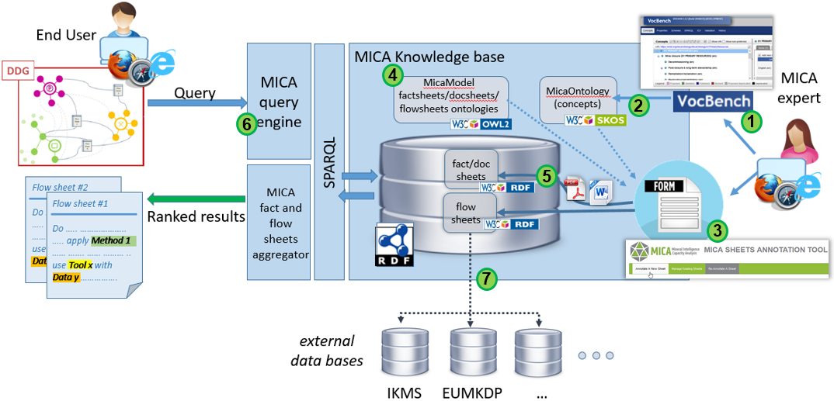

Figure 8 – MICA Architecture

### Implementation of MICA ontology

To define the MICA ontology we use SKOS vocabulary (Figure 9). Each concept is described with a SKOS predefined property (skos:prefLabel, skos:definition, etc. [[*https://www.w3.org/2004/02/skos/*](https://www.w3.org/2004/02/skos/)]). skos:broader properties connect concepts and sub-concepts (e.g., in Figure 3, D1 has a sub-concept PRIMARY RESOURCES which is specialised by MineralExploration, RegionalReconnaissance, PreliminaryStudies concepts). The skos:related property is used to link two concepts that are not hierarchically related (e.g., RegionalReconnaissance with PermittingLicensing).

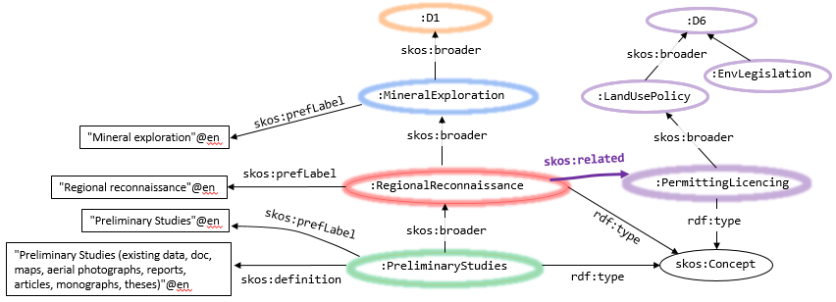

Figure 9 – SKOS ontology implementation

To help experts to build this ontology, the VocBench tool (Figure 10) has been deployed on a server (<http://lig-coin.imag.fr/vocbench-2.4.2/>). This tool allows the experts to consult and collaboratively create and modify the concepts hierarchies.

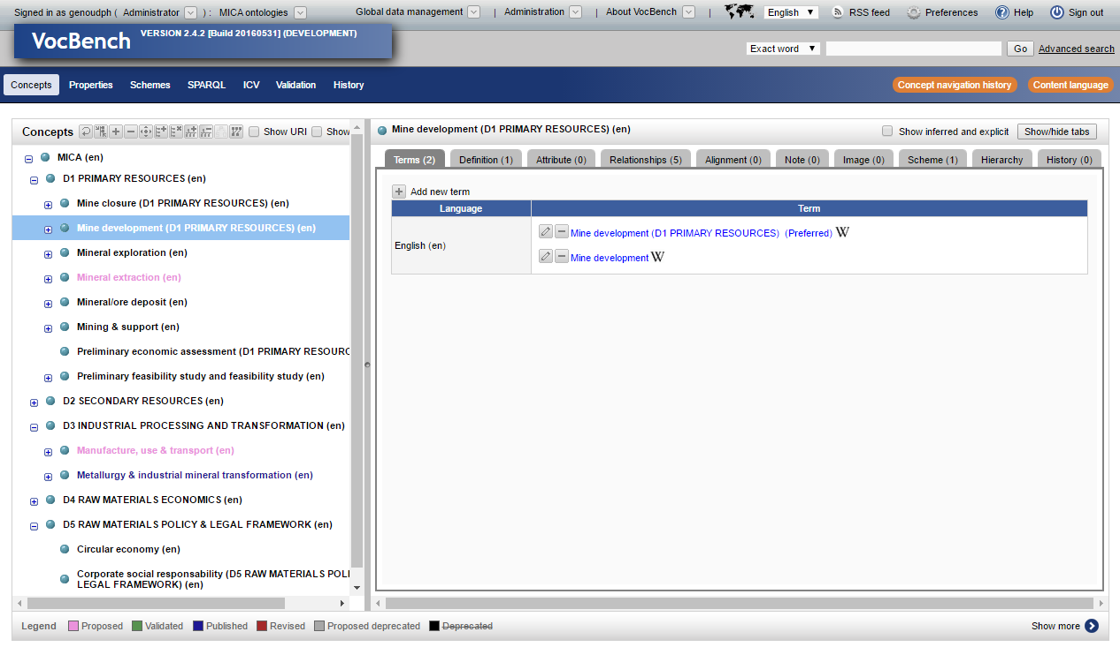

Figure 10 – VocBench user interface displaying MICA Main (domains) ontology.

### MICA sheets annotation

The factSheets and docSheets are linked to the MicaOntology concepts by the annotation process. The annotation process consists in selecting relevant concepts in the MICA ontology and in creating a RDF representation of the factSheet or docSheet using the MICA Model ontology (expressed in OWL [see Figure 8]) (Figure 11) and to insert it into the MICA database (TripleStore).

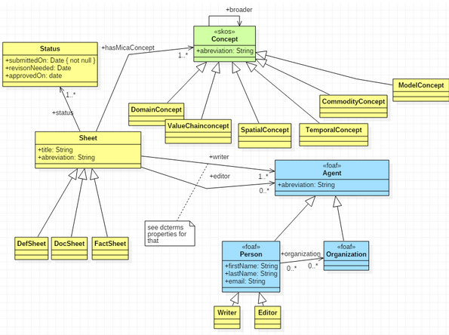

Figure 11 – MICA Model to represent fact, documentation and definition sheets.

To facilitate this process a web application (prototype accessible at <http://lig-coin.imag.fr/>) is under development (Figure 12).

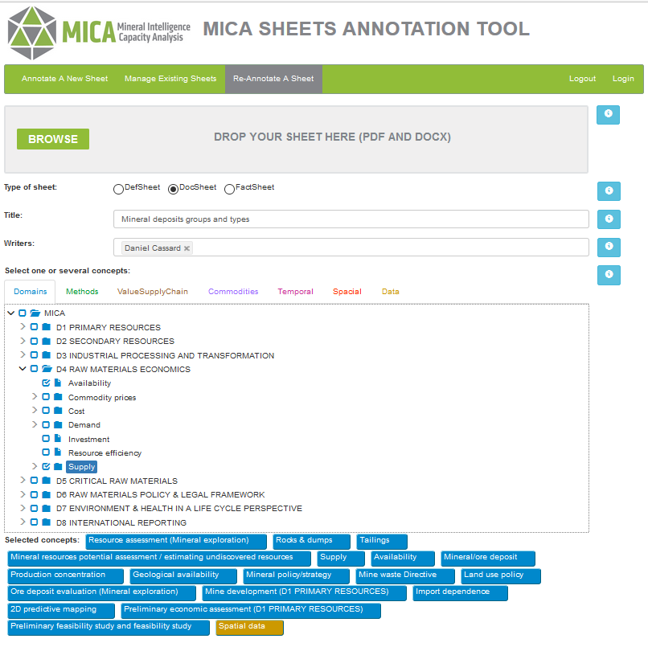

Figure 12: – Web interface to annotate a factSheet.

### Implementation of the queries

#### Queries from DDG to select FactSheet

To select fact or doc sheets, the end-user interacts with the DDG. These interactions result in SPARQL queries performed on the whole graph which is composed of RDF representations of fact and doc sheets, and MICA and Mica Model ontologies (extended by the inference mechanism of RDFs and OWL DL).

For example, *retrieve all factSheets about "Mining Wastes" with factSheets about related methods* corresponds to following SPARQL query:

SELECT DISTINCT ?fsd ?d ?fsm ?meth

WHERE {

{ ?fsd model:hasDomainConcept ?d.

FILTER( ?d = micavocab: Mining_Wastes ||   
 EXISTS {?d skos:broaderTransitive micavocab:Mining_Wastes})

}

OPTIONAL {

{ ?m skos:inScheme micavocab:MethodsScheme;

skos:related ?d.

{ ?fsm model:hasMethodConcept ?m.

BIND (?m as ?meth)

}

UNION {

?m1 skos:broaderTransitive ?m.

?fsm model:hasMethodConcept ?m1.

BIND (?m1 as ?meth)

}

}

UNION {

?d1 skos:broaderTransitive ?d.

?m skos:inScheme micavocab:MethodsScheme;

skos:related ?d1.

{ ?fsm model:hasMethodConcept ?m.

BIND (?m as ?meth)

}

UNION {

?m1 skos:broaderTransitive ?m.

?fsm model:hasMethodConcept ?m1.

BIND (?m1 as ?meth)

}

}

}

} ORDER by ?fsd ?fsm

The results of this query are shown on Figure 13.

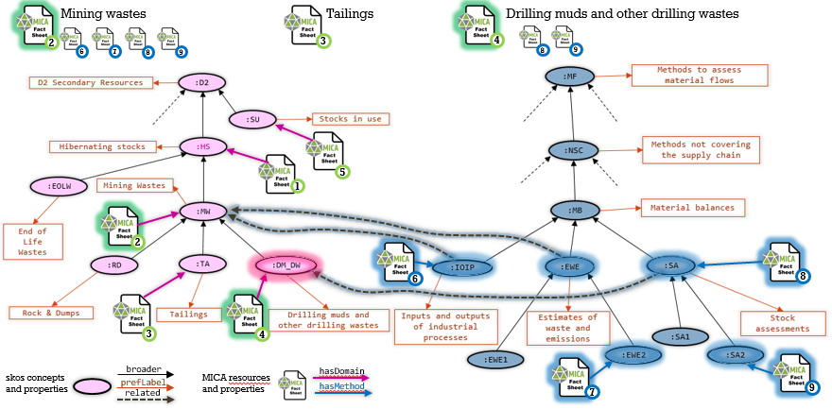

Figure 13 – Using the concepts hierarchy to retrieve factsheets and relevant methods.

#### Queries to external data sources

It is possible, to connect the RDF representation of a factSheet or a docSheet to external resources also described with RDF. This was experimented by connecting some factsheets to the E.U. law and publications database, and then performing some SPARQL federated queries.

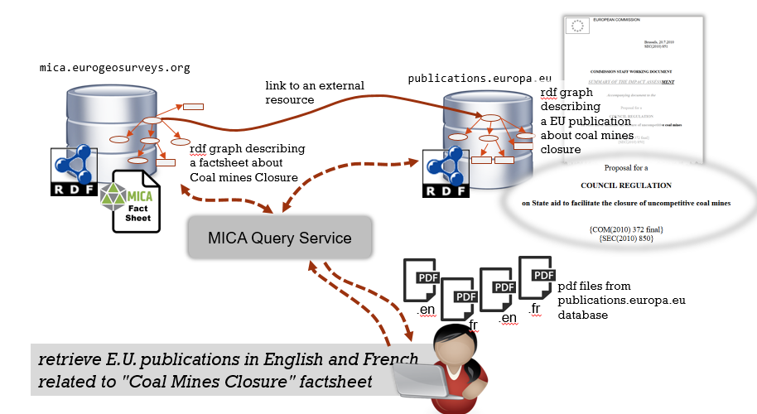

Figure 14 – Federated query to retrieve data form MICA database and external databases

### MICA’s development server

To share the current development with the different partners a GitHub private repository has been set up. It allows the invited partners to access documentation, source code of the different modules and current versions of the ontologies.

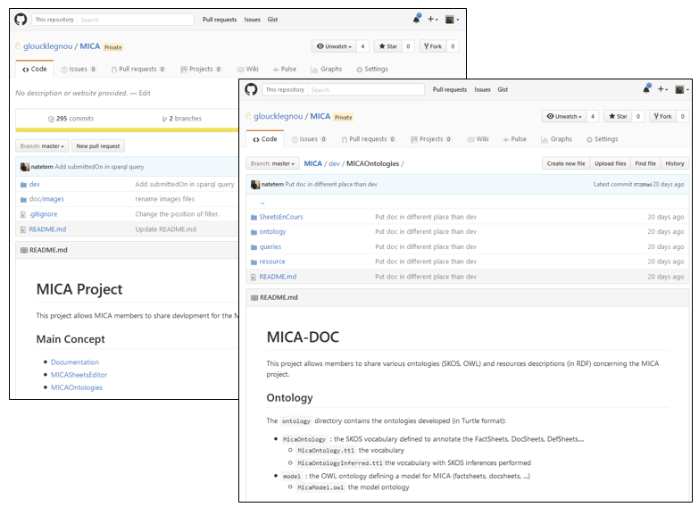

Figure 15 – MICA GitHub repository for WP6 developments.

## Prototype of the Dynamic Decision Graph (DDG)

The first version of the prototype (draft of) was presented during the 2nd MICA general meeting in September 2016. During the meeting several functional changes were agreed. The biggest change is the fact that the current version of the DDG is utilizing fully (on-line) the RDF TripleStore that contains both: the MICA Ontology as well as factSheets and in the near future flowSheets as well as docSheets.

This first on-line DDG Prototype (based on the JavaScript D3 visualization library) does not cover all the functionality agreed including the different Graphs to be offered to MICA users later on.

The visualization of the content of the MICA database follows the following strategy:

1. The main MICA ontology appears in the first step. At the same time in the side bar the list of all factSheets, flowSheets and docSheets (i.e., when ready) appears (Figure 16).
2. By selecting (by clicking) one main ontology domain (e.g., D4 RAW MATERIALS ECONOMICS) more detailed sub-concepts appear to the user and at the same time the list of factSheets, flowSheets, docSheets gets filter – showing only those related to the user selection of the concepts (Figure 17).

1. The user can continue “drilling” deeper in the sub-concept levels (Figure 18) in order to get most relevant set of factSheets, flowSheets and docSheets for his/her use case.

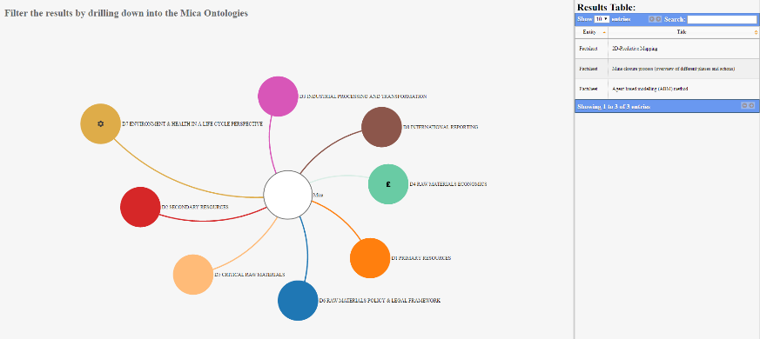

Figure 16 – Landing DDG Prototype page

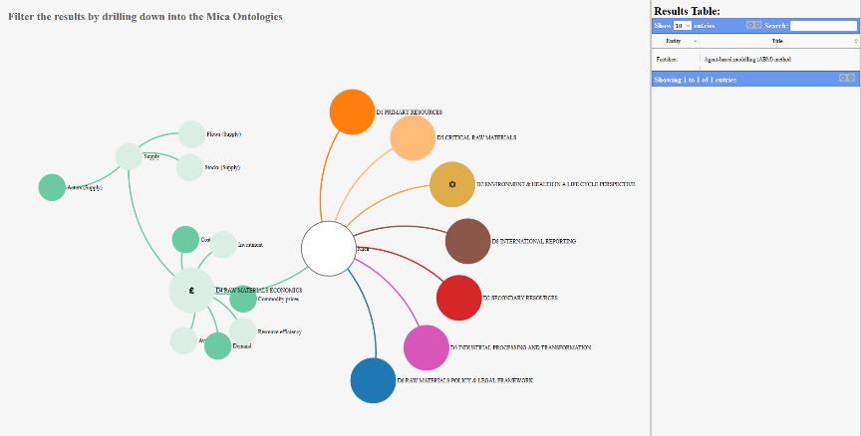

Figure 17 – Ontology selection and a consequent filtering of the factSheets

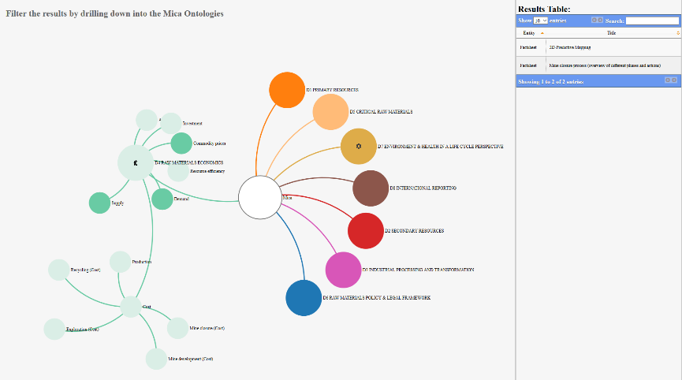

Figure 18 – Further sub-concepts (ontology) selection and a consequent filtering of the relevant factSheets

The work on the Prototype of DDG will continue and will reflect the additional agreed functionality, other options for visualization (e.g., weighted tree) and user guidance (interactive, step ways guidance) as well as the improved content of the MICA Database (RDF TripleStore).

The current version of the Prototype includes also a Help button to better guide users in the application.

## Concluding remarks

The present note, accompanying the release of a stabilized prototype of the MICA DDG, has been compiled by Daniel Cassard, Danielle Ziebelin and Robert Tomas. It summarizes all the work done by BRGM, BGS, GeoZS, GEUS, GTK, the JRC and the LIG on the development of the EU-RMICP, up to the end of 2016.

There is still some work for the finalization of the Main ontology itself (both perimeter and depth) and of the accompanying so-called TrOntos’, and one of the next challenges – not only for the WP6 Team, but also for the whole MICA Consortium - will be the production of all the necessary fact/flow/docSheets for having a high-performance system.

The prototype will now be tested by the MICA partners and their remarks/suggestions will be carefully taken into account to improve it and progressively elaborate a first version fully operational. This note will be updated accordingly.